桂林市社会福利医院2023年护士鞋采购要求

1. 采购物品：软底护士工作鞋
2. 材质：头层牛皮
3. 颜色：白色
4. 款式：具体款式未定，大致见下图
5. 数量：263双
6. 备注：其中 1双为带袢的款式（图1），其余262双款式见（图2）

图1

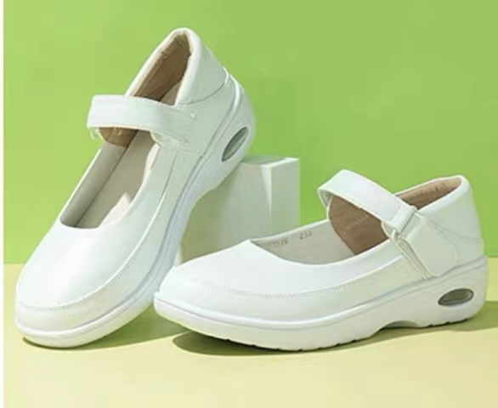

图2

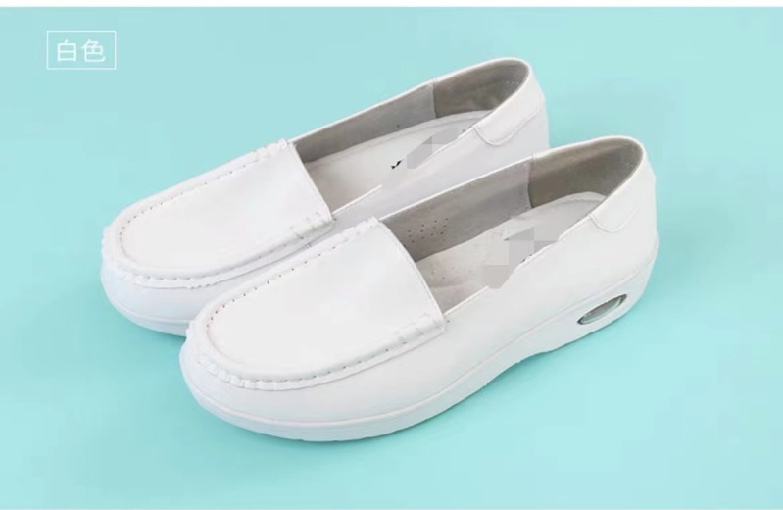

|  |  |  |  |  |  |  |  |  |  |  |  |  |  |  |  |  |  |  |  |  |  |  |  |
| --- | --- | --- | --- | --- | --- | --- | --- | --- | --- | --- | --- | --- | --- | --- | --- | --- | --- | --- | --- | --- | --- | --- | --- |
|  | 女鞋（皮鞋） | | | | | | | 女鞋合计 | 男鞋（皮鞋） | | | | | | | | | 男鞋合计 | | 合计 | | 备注 | |
| 鞋码 | 34 | 35 | 36 | 37 | 38 | 39 | 40 | 216 | 38 | 39 | 40 | 41 | 42 | 43 | 44 | 45 | 47 | | 263 | | 其中一双38码护士鞋需有鞋袢 | |
| 数量 | 4 | 19 | 45 | 65 | 48 | 24 | 11 | 1 | 3 | 5 | 6 | 15 | 13 | 4 | 0 |